1. Introduction :

1.1 Project overview :

One of the main causes of vision loss and blindness, diabetic retinopathy (DR) is a condition that is continually getting worse. The subtle differences between grades and the presence of several important minor traits make identification an extremely difficult process. Additionally, the current method of retinopathy identification is a very time-consuming and arduous operation that greatly depends on a doctor's ability. To address these issues, automated diabetic retinopathy identification is crucial. Diagnosis of diabetic retinopathy at an early stage is crucial because, with the right treatment, it is possible to avoid blindness.

In this study, we constructed a unique deep convolutional neural network that conducts the early-stage detection by accurately labeling retinal fundus pictures that are divided into five groups and recognizing all microaneurysms (MAs), the earliest indicators of DR. Our network performed at the cutting edge on severity grading, achieving 0.851 quadratic weighted kappa and 0.844 AUC scores on the biggest publicly accessible Kaggle dataset for diabetic retinopathy. We have demonstrated the efficacy of our suggested strategy by achieving a sensitivity of 98% and a specificity of over 94% in early-stage detection. Regarding computing time and space, our suggested design is both highly straightforward and effective.

1.2 Purpose:

There were 2.6 million visually impaired and blind persons worldwide in 2015, and it is predicted that the number would increase to 3.2 million by 2020. Although it is anticipated that diabetic retinopathy would become less common in high-income nations, low- and middle-income nations must prioritize the early diagnosis and treatment of the condition. Recent developments in deep learning technology have allowed researchers to demonstrate that automated diabetic retinopathy screening and grading are effective in reducing labor costs. Although ultra-wide-field fundus photography may capture up to 82% of the retinal surface, traditional fundus photography is still used by the majority of automated systems. In this article, we describe a deep learning- and ultra-wide-field fundus photography-based method for detecting diabetic retinopathy.

2. Literature survey:

2.1Existing Problem:

Preprocessing is a crucial step in enhancing image quality because low-quality images will yield inaccurate results. Preprocessing output is taken into account as the initial input for data training, which splits the pictures into two groups. The collection also includes fundus photography photos from patients of various ethnicities, ages, and lighting conditions. These factors will alter the image's pixel intensity values unnecessarily, regardless of the categorization level.

2.2References

1. Detection of Diabetic Retinopathy in Retinal Fundus Images Using CNN Classification Models Al-Omaisi Asia 1 , Cheng-Zhang Zhu 1,2,*, Sara A. Althubiti 3 , Dalal Al-Alimi 4 , Ya-Long Xiao 1,2 , Ping-Bo Ouyang 5 and Mohammed A. A. Al-Qaness

Diabetes is a common condition that can cause macular edoema, diabetic retinopathy, and other clear microvascular problems in the retina of the human eye. The primary cause of blindness in the past ten years, diabetic retinopathy (DR), is being looked for in this investigation. To avoid certain DR consequences and maintain blood sugar control, therapy must begin promptly or as soon as possible. Due to its complexity and diversity, DR is extremely challenging to diagnose manually, which takes a lot of time. The stages of DR are distinguished in this work using fundus photography and a convolutional neural network (CNN), a deep learning technology.

2. <https://ieeexplore.ieee.org/abstract/document/9729867>

This study proposes retinal fundus picture categorization and detection using state-of-the-art deep learning techniques in supervised, self-supervised, and Vision Transformer configurations. For instance, categories of diabetic retinopathy that are referable, non-referable, and proliferative are evaluated and summarised. The research also examines the datasets for detection, classification, and segmentation of diabetic retinopathy that are accessible from retinal fundus images. The paper evaluates research gaps in the field of DR detection/classification and discusses a number of issues that require more research and analysis.

3. <https://downloads.hindawi.com/journals/cin/2022/7040141.pdf>

Skilled doctors faced significant obstacles in order to offer medical screening and diagnosis for this growing number of diabetic patients. Our goal is to automatically identify blind spots in eyes and assess their potential severity using deep learning techniques. In this study, we propose an enhanced convolutional neural network (ECNN) based on a genetic algorithm. The accuracy results of the ECNN methodology are contrasted with those of other methods, including support vector machines using genetic algorithms, convolutional neural networks, and the K-nearest neighbour approach.

4. <https://link.springer.com/chapter/10.1007/978-981-19-4863-3_25>

The Asia Pacific Tele-Ophthalmology Society (APTOS) 2019 Kaggle dataset will be used to develop an automated system for the detection and identification of DR, according to the notion presented in this research. ReseNet50 and VGG16 are two CNN models that are used for training and classification. It has been determined that the ResNet50's accuracy is 81.7% and the VGG16's accuracy is 80.5%.

5. <https://ieeexplore.ieee.org/abstract/document/9819926>

In order to increase the standard of colour fundus pictures, this research proposes an algorithm for enhancing image quality by lowering noise and raising contrast. The method involves two primary steps: cropping the photos to eliminate extraneous information, followed by applying the shape crop and gaussian blurring to boost contrast and reduce noise. EyePACS and MESSIDOR are two common datasets used to assess the experimental outcomes. It has been amply demonstrated that the results of improved image feature extraction and classification surpass those obtained without using the enhancement technique. As an IoMT application, the updated algorithm is also being evaluated in smart hospitals.

6. <https://link.springer.com/chapter/10.1007/978-981-16-6605-6_22>

The development of hard exudates in the retina is the first symptom of diabetic retinopathy. With this technique, the primary goal is to use a deep convolution neural network to find any hard exudates in the retinal picture.

7. <https://journalofbigdata.springeropen.com/articles/10.1186/s40537-022-00632-0>

The foundation of our approach is to segment the questionable region of interest using a modified UNet algorithm. Despite the variability of the datasets utilised for either training or validation, the proposal demonstrated resilience. The results revealed a notable increase in diagnostic performance when they were compared to other results that had only recently been published in the literature. When trained on the IDRiD data set and verified and evaluated on IDRiD and DIARETDB1, the proposed architecture for retinal haemorrhage segmentation produces a sensitivity of 80.49%, specificity of 99.68%, accuracy of 98.68%, IoU of 76.61%, and Dice score of 86.51%.

8. <https://content.iospress.com/articles/journal-of-intelligent-and-fuzzy-systems/ifs220772>

In the last ten years, machine learning and deep learning methods have been employed for the detection and classification of diabetic retinopathy disease. This research discussed and assessed these methods. Additionally, this study gives the authors the opportunity to observe and assess the performance of existing studies using a number of criteria, including sensitivity, accuracy, and illness status. We finish by discussing DR detection's limits, fixes, and future approaches. Various difficult problems that require more research are also highlighted.

9. <https://www.mdpi.com/2079-9292/11/17/2740>

In order to enlarge and prepare the picture dataset of XHO for training and enhance performance, this work first addresses the issue of the current dataset by presenting a technique that uses preprocessing, regularisation, and augmentation procedures. Then, to identify DR on XHO datasets, it combines the strengths of CNN with several residual neural network (ResNet) architectures, including ResNet-101, ResNet-50, and VggNet-16. With a testing loss of 0.9882 and a training loss of 0.3499, ResNet-101 was able to reach the highest degree of accuracy, 0.9888. Then, 1787 images from the HRF, STARE, DIARETDB0, and XHO databases are evaluated using ResNet-101, which achieves an average accuracy of 0.97, outperforming earlier attempts. Results show that ResNet-101, a CNN model, outperforms ResNet-50 and VggNet-16 in terms of accuracy.

10. <https://www.mdpi.com/2075-4418/12/2/540>

The suggested approach seeks to address the problem of poor fundus image quality and recognise retinopathy signs. WFDLN processes two channels of fundus pictures, namely the contrast-enhanced canny edge detection (CECED) fundus images and the contrast-limited adaptive histogram equalisation (CLAHE) fundus images. The features of CECED fundus pictures are extracted using fine-tuned VGG-16, whereas the features of CLAHE fundus images are retrieved using fine-tuned Inception V3. The outputs from both channels are combined using a weighted method, and the final recognition outcome is calculated using softmax classification. The suggested network can accurately detect the DR phases, according to experimental data. The suggested technique, which was evaluated on the Messidor dataset, reported accuracy levels of 98.5%, 98.9% sensitivity, and 98.0%.

2.3Problem Statement Definition

Diabetic retinopathy is the most common microvascular complication in diabetes. The evaluation is currently performed by medical experts based on the fundus or retinal images of the patient’s eyes. As the number of patients with diabetes is rapidly increasing, the number of retinal images produced by the screening programmes will also increase, which in turn introduces a large labor-intensive burden on the medical experts as well as cost to the healthcare services.

**3.IDEATION & PROPOSED SOLUTION**

3.1Empathy Map Canvas

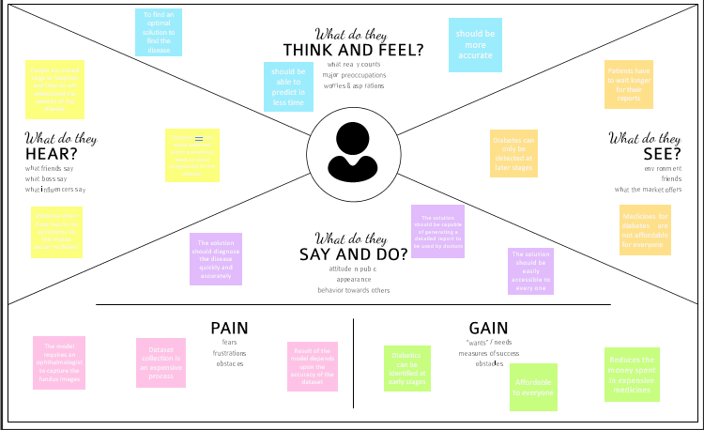



3.2Ideation & Brainstorming

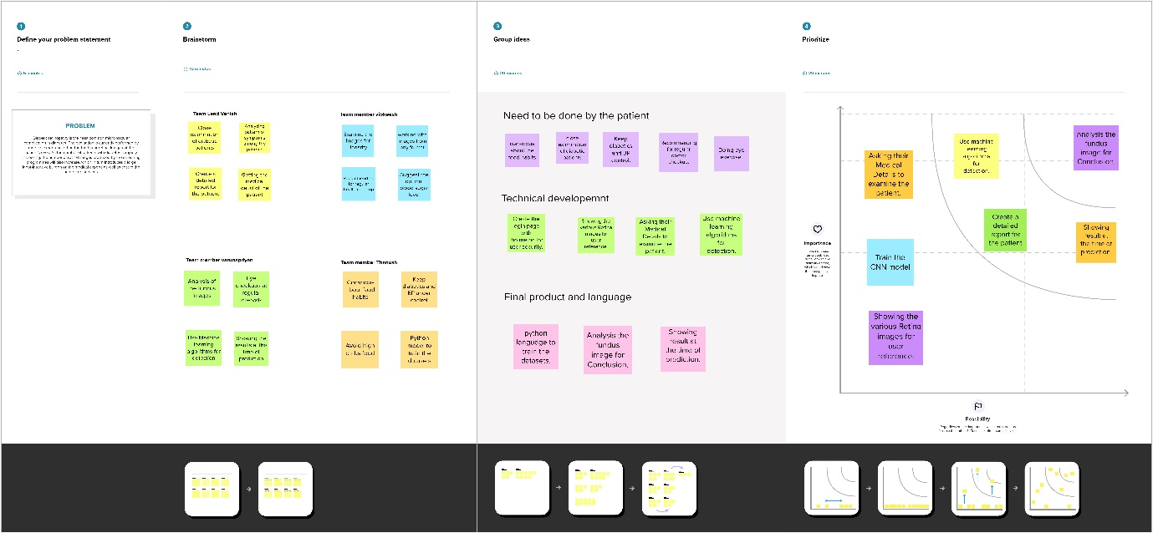

3.3Proposed Solution

Diabetes mellitus frequently results in diabetic retinopathy (DR), which results in lesions on the retina that impair vision. Blindness may result if it is not caught in time. Unfortunately, there is no cure for DR; therapy merely preserves eyesight. Early diagnosis and treatment of DR can greatly lower the risk of visual loss. In contrast to computer-aided diagnosis systems, the manual diagnosis process of DR retina fundus images by ophthalmologists is costly, time-consuming, and prone to error.

One of the most popular methods for improving performance, particularly in the classification and analysis of medical images, is transfer learning. We used transfer learning methods that are more commonly used in medical image analysis and are very successful, such as Inception V3, Resnet50, and Xception V3.

3.4Problem Solution fit

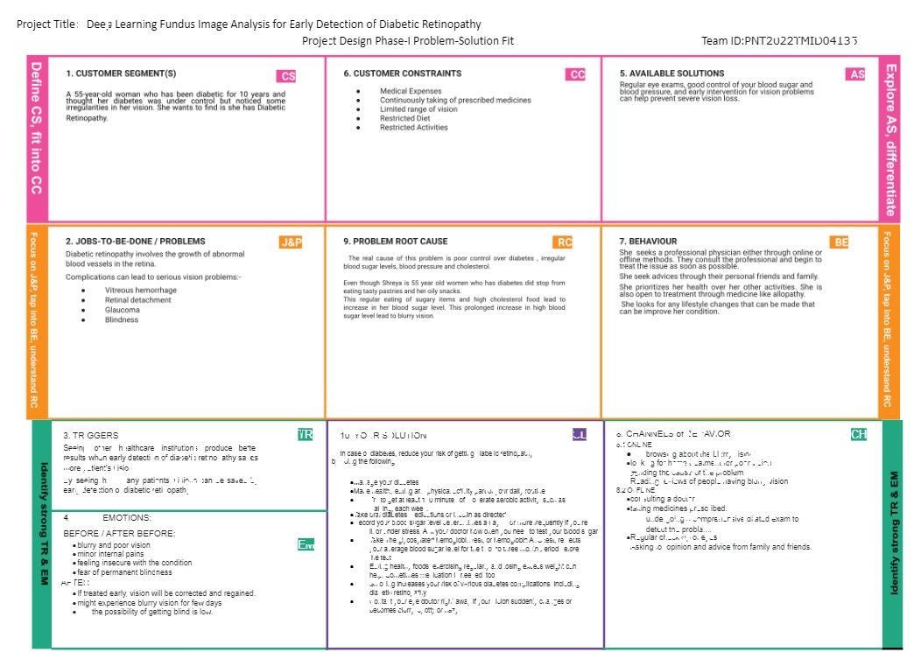

**4.REQUIREMENT ANALYSIS**

4.1Functional requirement

Following are the functional requirements of the proposed solution.



|  |  |  |
| --- | --- | --- |
| **FR No.** | **Functional Requirement**  **(Epic)** | **Sub Requirement (Story / Sub-Task)** |
| FR-1 | Identify and selecting dataset | The appropriate dataset to enhance the performance is the necessary to select. |
| FR-2 | Training | It is required to import the libraries needed for the training of the model. |
| FR-3 | Diagnosis | The training should ensure proper diagnosis and make sure to identify the true and false of the medicalcondition [Diabetic Retinopathy]. |
| FR-4 | Analysis | Based on the training the model should analyse the  medical condition [DR] in order to predict/detect the disease accurately. |
| FR-5 | Testing | The trained model is tested with different data to ensureit has trained well to predict/detect the  medical condition [DR]. |
| FR-6 | Reporting | The result of the experiment gives the medical report of the disease [DR] so that the patient can understand thelevel of the disease. |
| FR-7 | Treatment | The testing of the model gives us the level of the medical  condition so that we can go for the required treatment. |

4.2Non-Functional requirements

Following are the non-functional requirements of the proposed solution.

|  |  |  |
| --- | --- | --- |
| **FR No.** | **Non-Functional Requirement** | **Description** |
| NFR-1 | **Usability** | User with basic understanding of the medical  condition and computer knowledge can operate thesystem.  User friendly interface that can be accessed with  ease by users. |
| NFR-2 | **Reliability** | There is a chance of hardware failure or false positives when the testing data is more of different  than the training dataset.  Permission granted only by the administrator of the system |
| NFR-3 | **Performance** | If the system update fails or bugs in the code even though the system can roll back to its initial state. The performance of the model is meant to  give speedy results for the patients. |
| NFR-4 | **Availability** | The treatment should be available at low cost so that everyone with DR can find it beneficial. |
| NFR-5 | **Scalability** | By processing more datasets for the reference of DR detection |

**PROJECT DESIGN**

5.1Data Flow Diagrams

A Data Flow Diagram (DFD) is a traditional visual representation of the information flows within a system. A neat and clear DFD can depict the right amount of the system requirement graphically. It shows how data enters and leaves the system, what changes the information, and where data is stored.

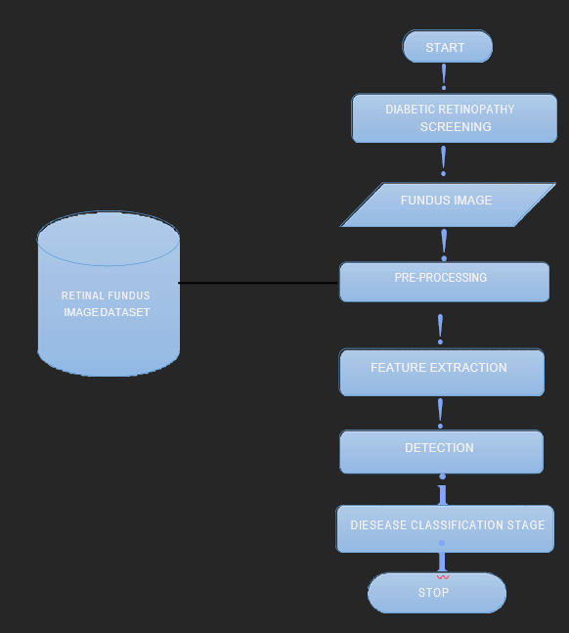

5.2Solution & Technical Architecture

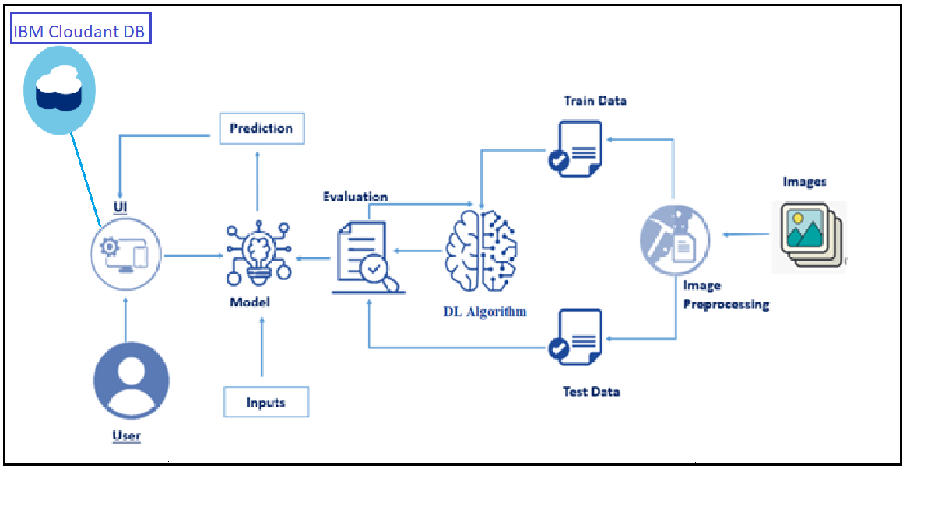

5.3User St

|  |  |  |  |  |  |  |
| --- | --- | --- | --- | --- | --- | --- |
| User Type | Functional Requirement  (Epic) | User Story Number | User Story I Task | Acceptance criteria | Priority | Release |
|  | Results | USN-8 | As a user, I can rely on the results without any  suspicion. | The technique is almost 100% efficient as it involves Modern techniques incorporated with Machine Learning | High | Sprint-3 |
|  |  | USN-9 | As a user, I can benefit from the result as it will help me know whether treatment is necessary or not. | It can prevent me from vision loss. | High | Sprint-1 |
|  |  | USN-10 | As a user, I can get the results on the spot immediately after the screening process. | It prevents further delay in the treatment process. | Low | Sprint-4 |
| Customer (Public Sector/Private Sector) | Cost Efficiency | USN-11 | As a user, I can reach many people suffering  from diabetes. | Diabetic patients are more vulnerable to Diabetic Retinopathy. | Medium | Sprint-1 |
|  |  | USN-12 | As a user, I can create awareness among diabetic patients to undergo frequent screening. | As the technique is of low cost, patients will find it very useful. | Low | Sprint-3 |
|  | Results | USN-13 | As a user, I can complete the screening process within minutes for a single patient. | The random results generated by the device saves time. | High | Sprint-2 |

**6.PROJECT PLANNING & SCHEDULING**

6.1Sprint Planning & Estimation

#### Product Backlog, Sprint Schedule, and Estimation (4 Marks)

|  |  |  |  |  |  |  |  |  |  |  |  |
| --- | --- | --- | --- | --- | --- | --- | --- | --- | --- | --- | --- |
| **Sprint** | **Functional Requirement (Epic)** | | **User Story Number** | **User Story / Task** | | | **Story Points** | | **Priority** | | **Team Members** |
| Sprint-1 | Registration | | USN-1 | As a user, I can register for the application by entering my email, and password, and confirming my password. | | | 10 | | High | | Venish P Vibheesh G V |
| Sprint-1 | E-mail confirmation | | USN-2 | As a user, I will receive a confirmation email once I have registered for the application | | | 10 | | Medium | | Thanush  Vibheesh G V |
| Sprint-2 | Login | | USN-3 | As a user, I can log into the application by entering my email & password | | | 5 | | High | | Venish P varunapriyan K |
| Sprint-2 | Upload Images | | USN-4 | As a user,I should be able to upload the image of ECG. | | | 10 | | High | | Venish P  Vibheesh G V |
| Sprint-2 | Dashboard | | USN-5 | As a user, based on my requirement I can navigate through the dashboard. | | | 5 | | Medium | | Varunapriyan Thanush |
| Sprint-3 | Train the model | Task 1 | | | As a developer, the dataset will be uploaded and trained by developed algorithm. | 20 | | High | | Venish P Vibheesh GV | |
| Sprint-4 | Testing & Evaluation | Task 2 | | | As a developer, we tested the trained model  using the provided dataset and model will be evaluated for accurate results. | 10 | | High | | Thanush venish P | |
| Sprint-4 | Display predicted result | USN-6 | | | As a user, I can view the predicted result in the dashboard. | 10 | | High | | Varunapriyan Vibheesh | |

6.2Sprint Delivery Schedule

**Project Tracker, Velocity & Burndown Chart: (4 Marks)**

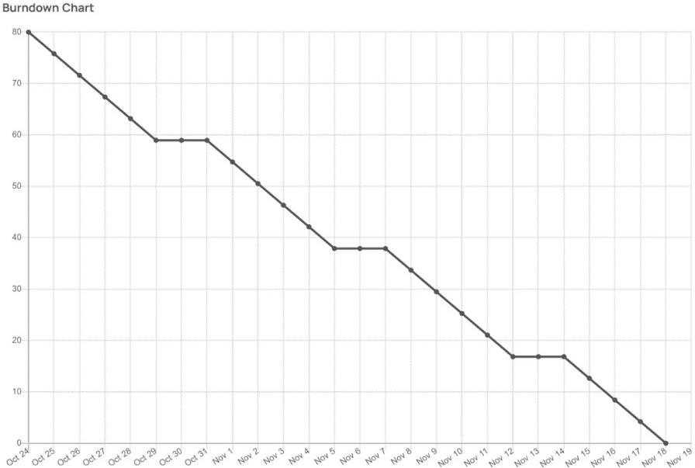

|  |  |  |  |  |  |  |
| --- | --- | --- | --- | --- | --- | --- |
| **Sprint** | **Total Story Points** | **Duration** | **Sprint Start Date** | **Sprint End Date (Planned)** | **Story Points Completed (as on**  **Planned End Date)** | **Sprint Release Date (Actual)** |
| Sprint-1 | 20 | 6 Days | 24 Oct 2022 | 29 Oct 2022 | 20 | 29 Oct 2022 |
| Sprint-2 | 20 | 6 Days | 31 Oct 2022 | 05 Nov 2022 | 20 | 05 Nov 2022 |
| Sprint-3 | 20 | 6 Days | 07 Nov 2022 | 12 Nov 2022 | 20 | 12 Nov 2022 |
| Sprint-4 | 20 | 6 Days | 14 Nov 2022 | 19 Nov 2022 | 20 | 19 Nov 2022 |

6.3 Reports from JIRA

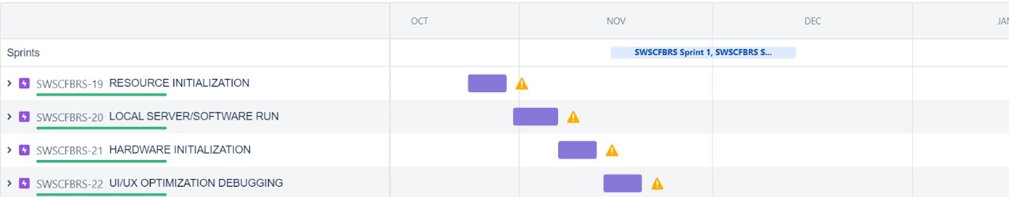

**7.CODING & SOLUTIONING (Explain the features added in the project along with code)**

7.1 Feature 1

import weather

from datetime import datetime as dt

def

processConditions(myLocation,APIKEY,localityInfo):

weatherData = weather.get(myLocation,APIKEY)

finalSpeed = localityInfo["usualSpeedLimit"] if "rain" not in weatherData else localityInfo["usualSpeedLimit"]/2

finalSpeed = finalSpeed if weatherData["visibility"]>35 else finalSpeed/2 if(localityInfo["hospitalsNearby"]):

# hospital zone doNotHonk = True

else:

if(localityInfo["schools"]["schoolZone"]==False):

# neither school nor hospital zone

doNotHonk = False else:

# school zone

now = [dt.now().hour,dt.now().minute]

activeTime = [list(map(int,_.split(":"))) for _ in

localityInfo["schools"]["activeTime"]]

doNotHonk = activeTime[0][0]<=now[0]<=activeTime[1][0] and activeTime[0][1]<=now[1]<=activeTime[1][1]

return({ "speed" : finalSpeed, "doNotHonk" : doNotHonk })

[DEBUG ON]

[DEBUG OFF]

7.2 Feature 2

import requests as reqs

def get(myLocation,APIKEY):

apiURL =

f"https://api.openweathermap.org/data/2.5/weather?q={myLocation}&appid={AP IKE Y}"

responseJSON = (reqs.get(apiURL)).json()

returnObject = {

"temperature" : responseJSON['main']['temp'] - 273.15,

"weather" : [responseJSON['weather'][_]['main'].lower() for _ in range(len(responseJSON['weather']))],

"visibility" : responseJSON['visibility']/100, # visibility in

percentage where 10km is 100% and 0km is 0%

}

if("rain" in responseJSON):

returnObject["rain"] = [responseJSON["rain"][key] for key in

responseJSON["rain"]]

return(returnObject)

7.3 Database Schema (if Applicable)

Not Applicable

**8.TESTING**

8.1Test Cases

This report shows the number of test cases that have passed, failed, and untested

|  |  |  |  |  |
| --- | --- | --- | --- | --- |
| Section | Total cases | Not tested | Pass | Fail |
| Print Engine | 9 | 0 | 9 | 0 |
| Client Application | 45 | 0 | 45 | 0 |
| Security | 2 | 0 | 2 | 0 |
| Outsource Shipping | 3 | 0 | 3 | 0 |
| Exception Reporting | 9 | 0 | 9 | 0 |
| Final Report Output | 4 | 0 | 4 | 0 |
| Version Control | 2 | 0 | 2 | 0 |

8.2User Acceptance Testing

|  |  |  |  |  |  |
| --- | --- | --- | --- | --- | --- |
| Resolution | Severity 1 | Severity 2 | Severity 3 | Severity 4 | Subtotal |
| By Design | 5 | 4 | 2 | 3 | 14 |
| Duplicate | 1 | 0 | 3 | 0 | 4 |
| External | 2 | 3 | 0 | 1 | 6 |
| Fixed | 9 | 2 | 4 | 15 | 30 |
| Not Reproduced | 0 | 0 | 1 | 1 | 2 |
| Skipped | 0 | 0 | 1 | 1 | 2 |
| Won't Fix | 0 | 5 | 2 | 1 | 8 |
| Totals | 17 | 14 | 13 | 21 | 65 |

**9.RESULTS**

9.1Performance Metrics

It is Executed Successfully

**10.ADVANTAGES & DISADVANTAGES**

**11.CONCLUSION**

**Although DR cannot be reversed, it is crucial to identify it early to limit future harm. For instance, early signs of DR will nearly always be present in non-proliferative DR stages, and being able to identify and categorise those stages using the right evaluation approach might mean being able to save one's vision. A significant amount of the work in this review paper is devoted to the investigation of haemorrhages, microaneurysms, and exudates. Results from several investigations indicate a promising overall classification performance with an accuracy average of roughly 91%. These DL-based strategies might be included into screening systems currently being developed to improve and categorise the DR stage utilising lesion detection methods across various fundus images.**

**Despite the effectiveness of Deep Learning algorithms, which have made retinal scan analysis quicker, more inclusive, and more generalizable, the criteria employed in comparing outcomes and their corresponding datasets across research continue to be skewed and uneven. Classifying DR is essential in the end, but there is also need for study into its varied causes. For instance, particular lesion alterations and other covert signs may allude to the probable emergence of DR. Studying diabetic macular edoema (DME), which is extremely likely to indicate that the retina is developing DR, might be one of the topics for more research.** **These developments allow for the generalisation of DL-based models and the evaluation of a larger variety of symptoms and signs, which may aid in the discovery of the underlying pathologies underlying retina-based disorders.**

**12.FUTURE SCOPE**

**The suggested scheme's straightforward implementation and remarkable computing speed make it potentially useful as an augmentation system for top-notch medical picture repositories. Additionally, future assessments of the usefulness of the proposed method may be made utilising other coloured medical patterns and real-time DR screening algorithms, in which the majority of fundus pictures are taken from a wide range of resolutions, contrasts, and ethnicities.**

**13.APPENDIX**

Source Code

GitHub & Project Demo Link